**DAILY ONLINE ACTIVITIES SUMMARY**

|  |  |  |  |
| --- | --- | --- | --- |
| **Date:** | 17/07/2020 | **Name:** | Krishnitha |
| **Sem & Sec** | 4th sem, A Section | **USN:** | 4AL18CS039 |
| **Online Test Summary** | | | |
| **Subject** | Data Communication | | |
| **Max. Marks** | 30 | **Score** | NA |
| **Certification Course Summary** | | | |
| **Course** | Data Scientist | | |
| **Certificate Provider** | AWS | **Duration:** | 3 hrs |
| **Coding Challenges** | | | |
| **Problem Statement:**  Reverse words in a given String in Python. | | | |
| **Status:** Executed | | | |
| **Uploaded the report in GitHub** | | YES | |
| **If yes Repository name** | | <https://github.com/krishnitha/Python-coding> | |
| **Uploaded the report in slack** | | YES | |

**Descriptive Test Details:**

Today we had test in “Data Communication” subject. The assessment was based on first module of this subject. The test consisted of four questions, two questions of 8 marks and other of 7 marks.

**Certification Course Details:**

Today I continued the course “Data Scientist” by AWS. Today I learnt about Data structures, data warehouse, Relational and non-relational data structures. I also completed the assignments of this module.

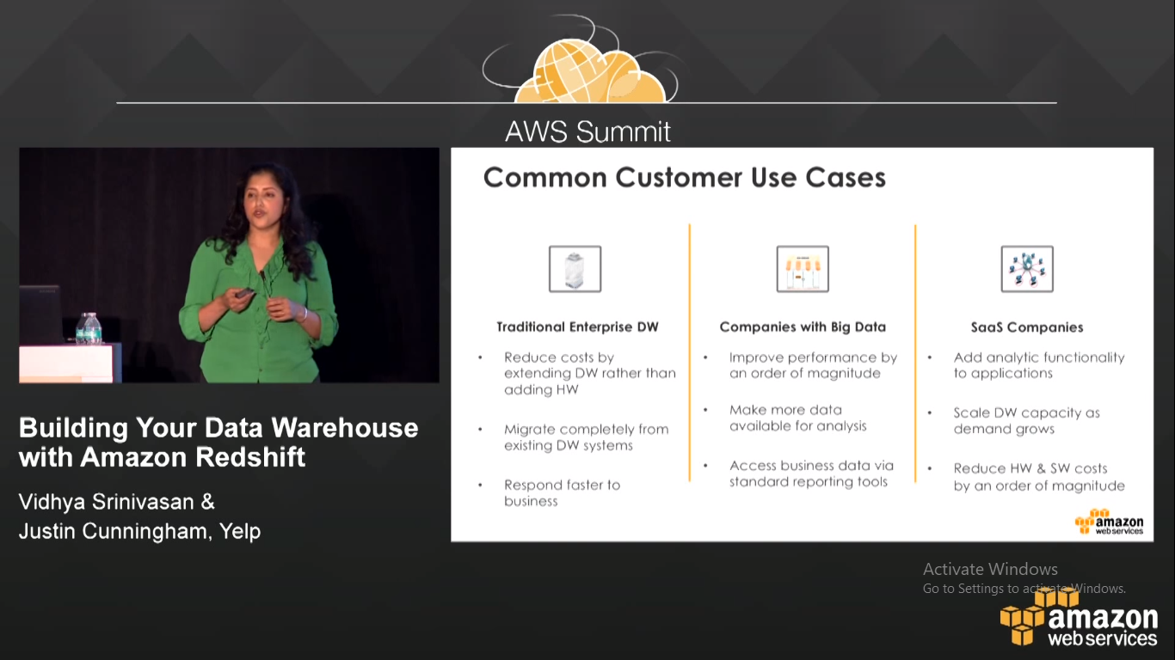

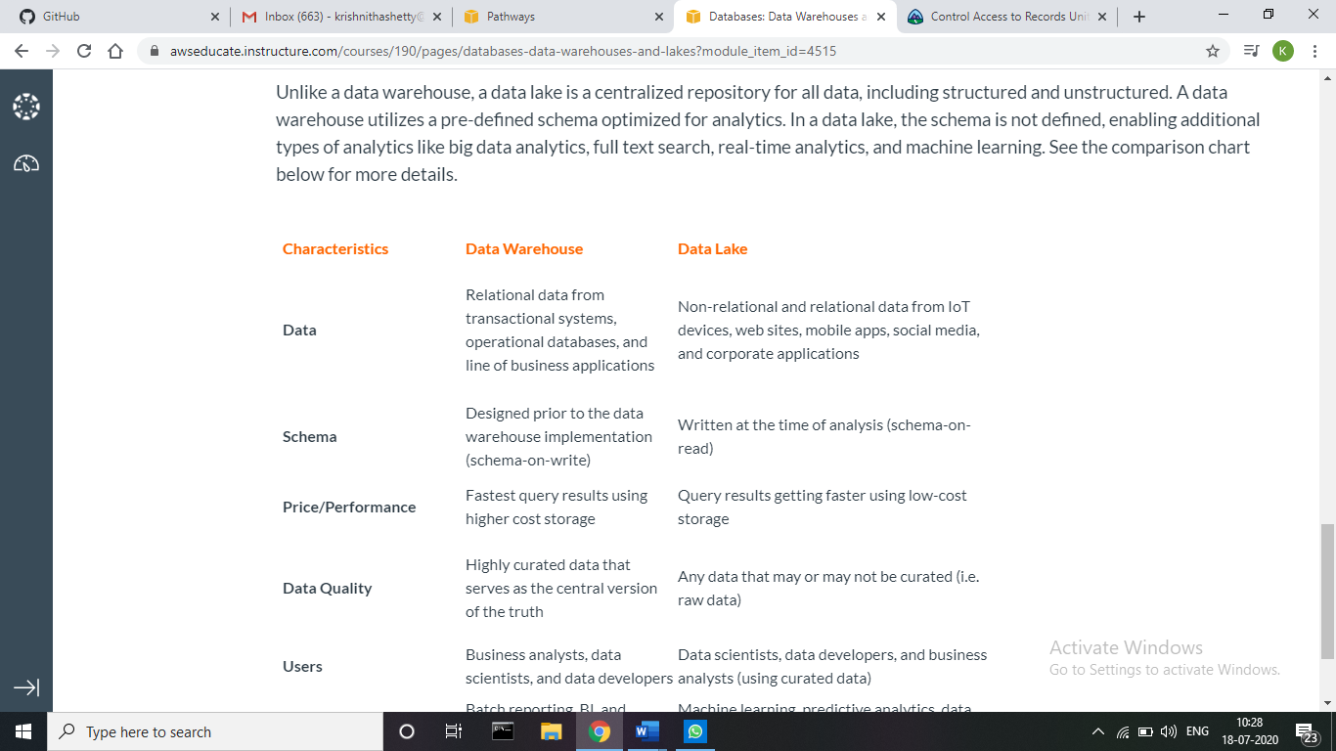

**Coding Challenges Details:**

**Problem:** Reverse words in a given String in Python.

We are given a string and we need to reverse words of given string.

**Examples:**

Input: str = "AIET CHALLENGES IIT"  
Output: str = "IIT CHALLENGES AIET"

**Solution:** Uploaded it in GitHub

